**DBMS LAB TASK 1**

Name: Kommaraju Jahnavi

Reg No. : 121910306007

Section: B6

**1)Construct an ER Model of University Database.**

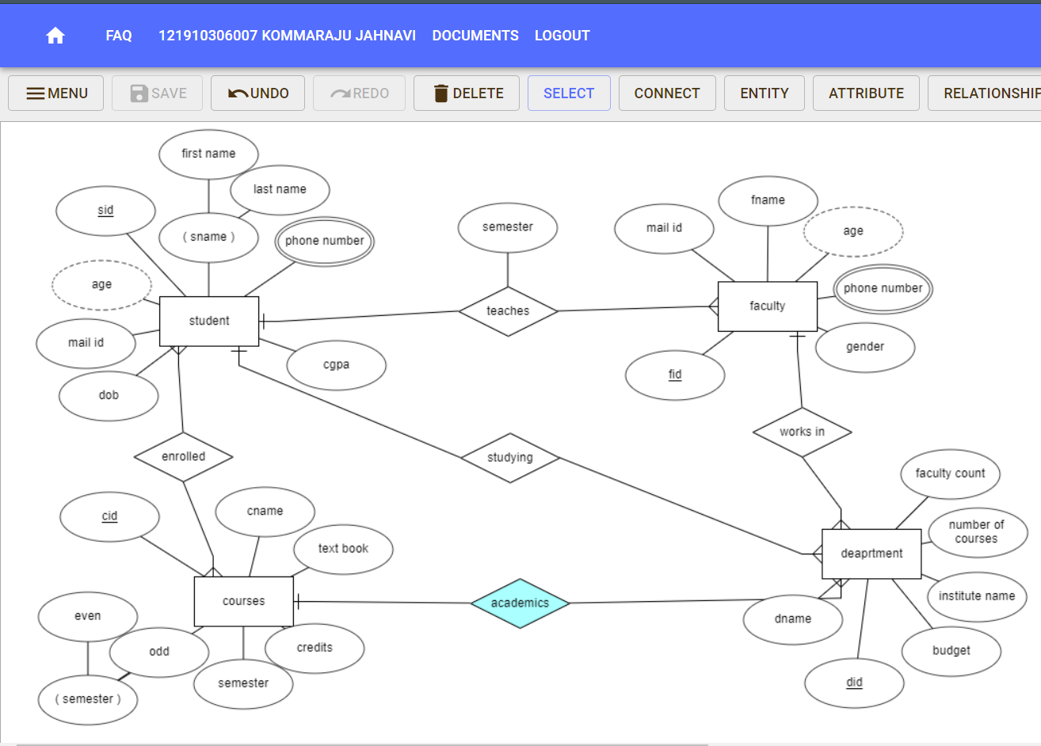

**2) A university database contains information about professors (identified by social security number, or SSN) and courses (identified by courseid). Professors teach courses; each of the following situations concerns the Teaches relationship set. For each situation, draw an ER diagram that describes it (assuming no further constraints hold)**

**2.1)Professors can teach the same course in several semesters, and each offering must be recorded.**

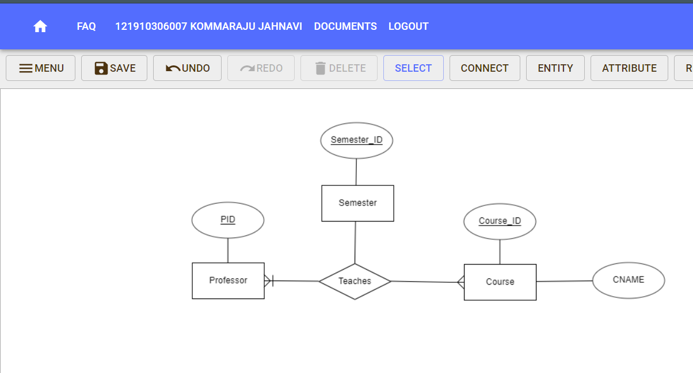

**2.2) Professors can teach the same course in several semesters, and only the most recent such offering needs to be recorded. (Assume this condition applies in all subsequent questions.)**

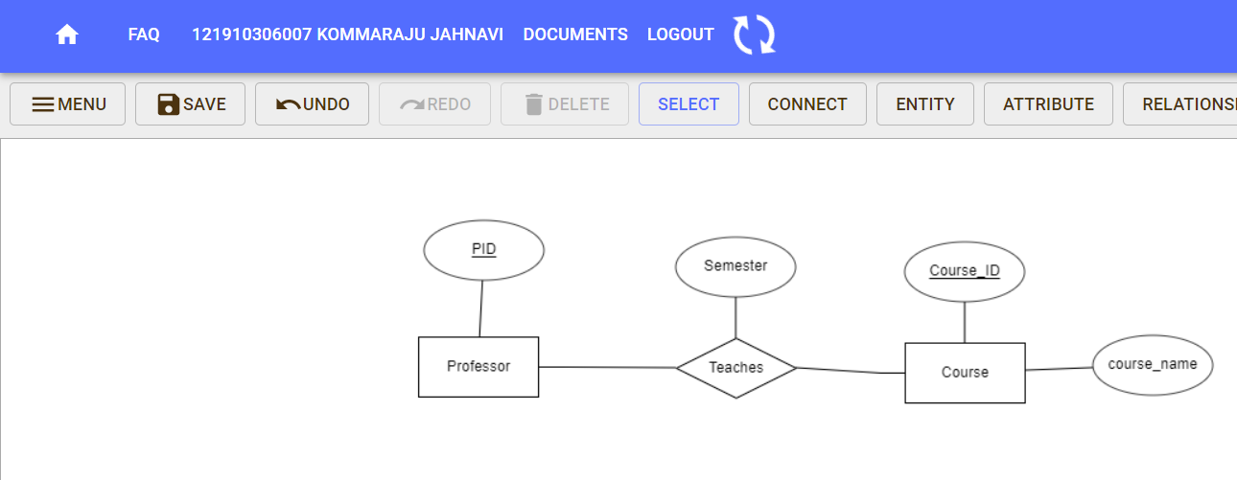

**2.3) Every professor must teach some course.**

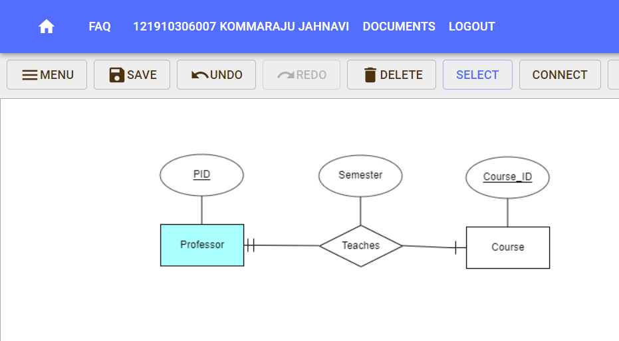

**2.4) Every professor teaches exactly one course (no more, no less).**

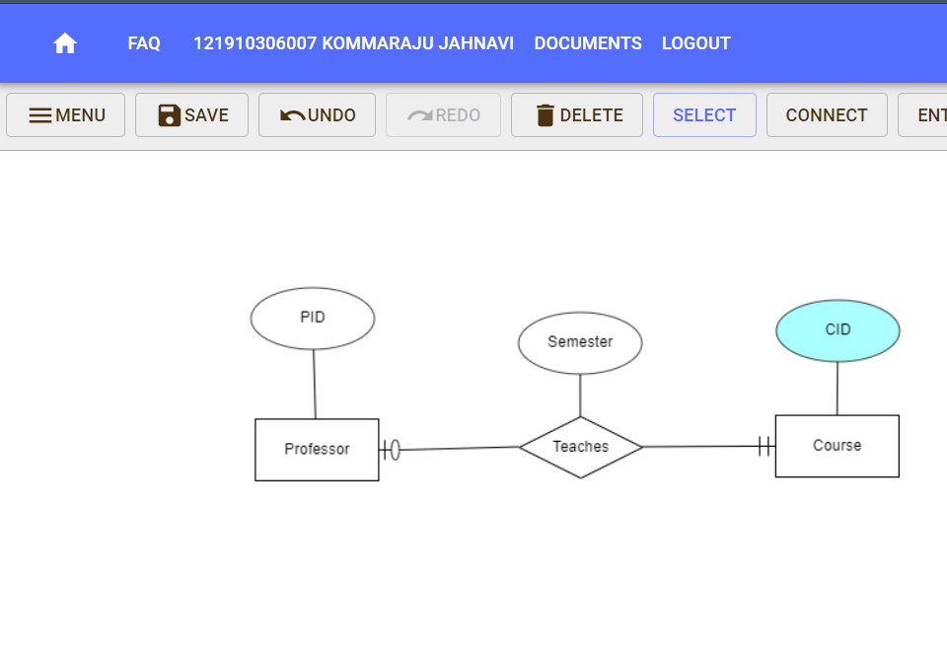

**2.5) Every professor teaches exactly one course (no more, no less), and every course must be taught by some professor.**

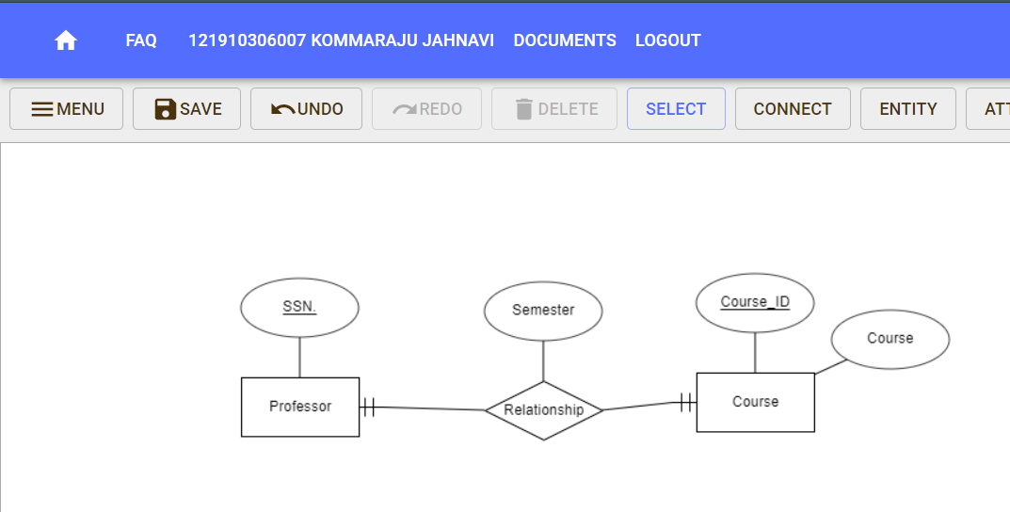

**3) A company database needs to store information about employees (identified by ssn, with salary and phone as attributes), departments (identified by dno, with dname and budget as attributes), and children of employees (with name and age as attributes). Employees work in departments; each department is managed by an employee; a child must be identified uniquely by name when the parent (who is an employee; assume that only one parent works for the company) is known. We are not interested in information about a child once the parent leaves the company. Draw an ER diagram that captures this information.**

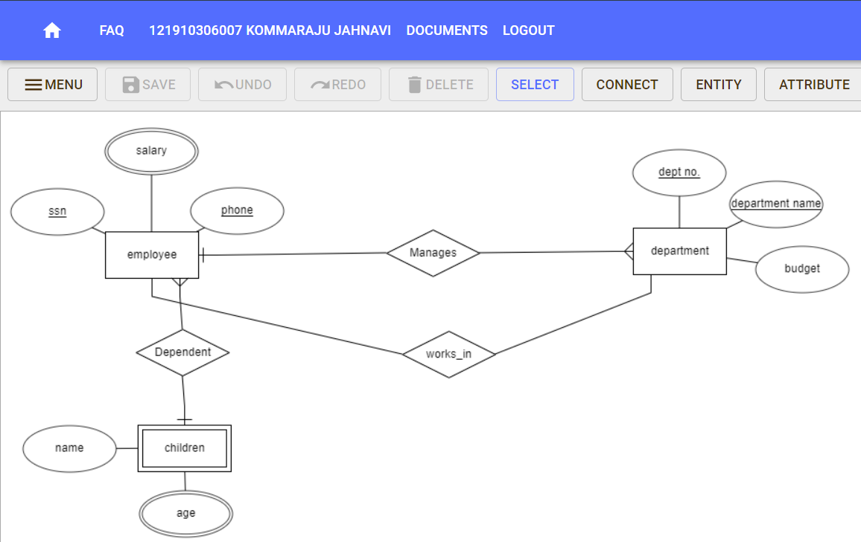

**4) Construct an ER Model of Railway Reservation Management system**

